CNN for Sentimental Analysis

1. Quá trình huấn luyện

Epoch 1/10

2334/2334 [==============================] - 34s 14ms/step - loss: 0.8522 - accuracy: 0.6574 - val_loss: 0.4279 - val_accuracy: 0.8559

Epoch 2/10

2334/2334 [==============================] - 32s 14ms/step - loss: 0.4392 - accuracy: 0.8388 - val_loss: 0.2308 - val_accuracy: 0.9399

Epoch 3/10

2334/2334 [==============================] - 33s 14ms/step - loss: 0.2517 - accuracy: 0.9085 - val_loss: 0.2186 - val_accuracy: 0.9449

Epoch 4/10

2334/2334 [==============================] - 39s 17ms/step - loss: 0.1663 - accuracy: 0.9396 - val_loss: 0.2327 - val_accuracy: 0.9510

Epoch 5/10

2334/2334 [==============================] - 35s 15ms/step - loss: 0.1280 - accuracy: 0.9521 - val_loss: 0.2402 - val_accuracy: 0.9510

Epoch 6/10

2334/2334 [==============================] - 34s 15ms/step - loss: 0.1111 - accuracy: 0.9569 - val_loss: 0.2546 - val_accuracy: 0.9530

Epoch 7/10

2334/2334 [==============================] - 38s 16ms/step - loss: 0.1029 - accuracy: 0.9596 - val_loss: 0.2677 - val_accuracy: 0.9570

Epoch 8/10

2334/2334 [==============================] - 36s 15ms/step - loss: 0.0964 - accuracy: 0.9617 - val_loss: 0.2891 - val_accuracy: 0.9520

Epoch 9/10

2334/2334 [==============================] - 34s 15ms/step - loss: 0.0945 - accuracy: 0.9627 - val_loss: 0.2856 - val_accuracy: 0.9560

Epoch 10/10

2334/2334 [==============================] - 36s 15ms/step - loss: 0.0922 - accuracy: 0.9635 - val_loss: 0.3221 - val_accuracy: 0.9530

1. Độ chuẩn xác

Validation loss: 0.3221342861652374

Validation accuracy: 0.9529529809951782

1. AUC và ROC

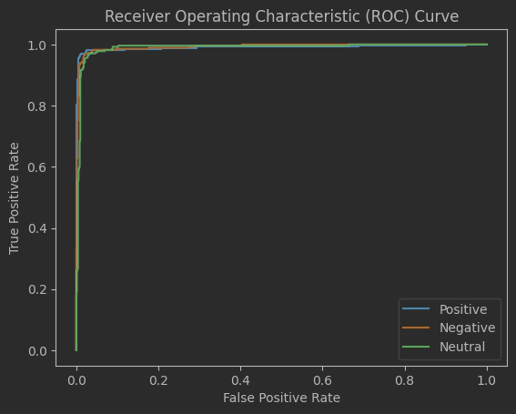

AUC (Positive): 0.9904245607196709

AUC (Negative): 0.9928055432699396

AUC (Neutral): 0.9899371981159434

1. Bảng thống kê

|  |  |  |  |  |
| --- | --- | --- | --- | --- |
|  | precision | recall | f1-score | support |
| Irrelevant | 0.96 | 0.94 | 0.95 | 171 |
| Negative | 0.96 | 0.97 | 0.97 | 266 |
| Neutral | 0.95 | 0.96 | 0.96 | 285 |
| Positive | 0.95 | 0.95 | 0.95 | 277 |

|  |  |  |  |  |
| --- | --- | --- | --- | --- |
| accuracy |  |  | 0.96 | 999 |
| macro avg | 0.96 | 0.96 | 0.96 | 999 |
| weighted avg | 0.96 | 0.96 | 0.96 | 999 |